Mission and Vision Statement of the Memorial Project
Mission Statement
To commemorate the life and work of Dr. Martin Luther King, Jr. by leading a collaborative funding, design, and construction process in the creation of a memorial to honor his national and international contributions to world peace through non-violent social change.
Vision Statement
Dr. King championed a movement that draws fully from the deep well of America's potential for freedom, opportunity, and justice. His vision of America is captured in his message of hope and possibility for a future anchored in dignity, sensitivity, and mutual respect; a message that challenges each of us to recognize that America's true strength lies in its diversity of talents. The vision of a memorial in honor of Martin Luther King, Jr. is one that captures the essence of his message, a message in which he so eloquently affirms the commanding tenants of the American Dream — Freedom, Democracy and Opportunity for All; a noble quest that gained him the Nobel Peace Prize and one that continues to influence people and societies throughout the world. Upon reflection, we are reminded that Dr. King's lifelong dedication to the idea of achieving human dignity through global relationships of well being has served to instill a broader and deeper sense of duty within each of us— a duty to be both responsible citizens and conscientious stewards of freedom and democracy.

About the Memorial
Site Location - Context
The National Capital Planning Commission and the U.S. Commission of Fine Arts approved the site location for the King Memorial on the National Mall in Washington, DC December 1999.
The Memorial’s address will be 1964 Independence Ave, SW, Washington, DC 20024. The street number is a reference to the Civil Right’s Act of 1964, a milestone which Dr. King played an integral role in achieving.
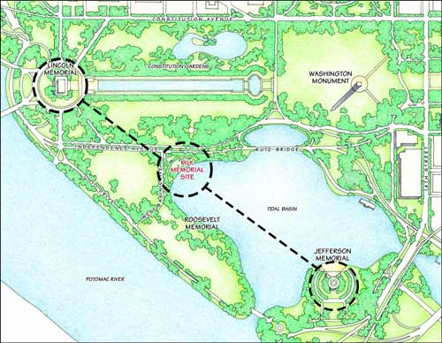
The approved site creates a visual "line of leadership" from the Lincoln Memorial, which honors the President who protected the United States from internal strife, and where Martin Luther King Jr. gave his famous "I Have a Dream" speech; to the Jefferson Memorial, which honors the President who helped create the United States as the author of the Declaration of Independence.
Site Location - Memorial
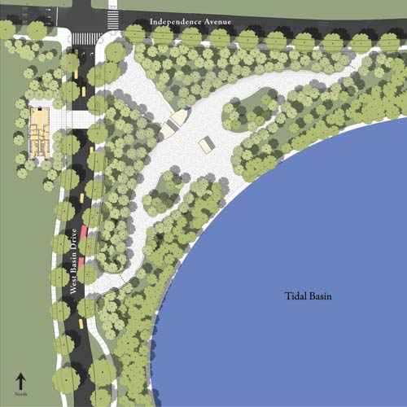
For more information on the King Memorial site plan, please visit our Construction Update page.
Dr. King's Memorial is situated on a four-acre plot on the northwest corner of the Tidal Basin adjacent to the Roosevelt Memorial. The Tidal Basin is a man made body of water to the south of the National Mall which acts as an overflow catch basin when the Potomac River swells, helping to prevent extensive flooding of the Mall.
The site is situated within the precinct of Washington, DC’s famous cherry blossom trees, a gift from Japan as a sign of peace. Before the King Memorial was built, millions of visitors would come to Washington, DC each spring to witness the beauty of the two week blooming period. During this short timeframe, the Tidal Basin is surrounded by delicate pink and white blossoms on hundreds of trees, a vision that enhances the experience of the Nation’s Capital, and announces the arrival of spring each year to its residents.
Site | Design Elements | Composition and Space | Dr. King's Spiritual Presence
Design & Construction Team

About the Memorial
Sculpture
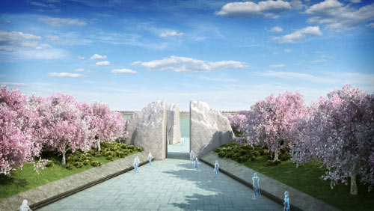
At the entry portal, two stones are parted and a single stone wedge is pushed forward toward the horizon; the missing piece of what was once a single boulder. The smooth insides of the portal contrast the rough outer surfaces of the boulder. Beyond this portal, the stone appears to have been thrust into the plaza, wrested from the boulder and pushed forward – it bears signs of a great monolithic struggle.
On the visible side of the stone, the theme of hope is presented, with the text from King's famed 1963 speech cut sharply into the stone: "Out of the mountain of despair a stone of hope." On the other side are inscribed these words: "I was a drum major for justice, peace and righteousness”, a statement suggested by Dr. King himself when describing how he would like to be remembered.
The boulder is the Mountain of Despair, through which every visitor will enter, moving through the struggle as Dr. King did during his life, and then be released into the open freedom of the plaza. The solitary stone is the Stone of Hope, from which Dr. King’s image emerges, gazing over the Tidal Basin toward the horizon, seeing a future society of justice and equality for which he encouraged all citizens to strive.
Inscription Wall
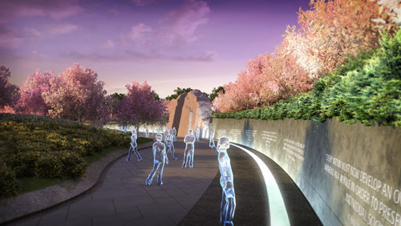
The element of the memorial which truly captures Dr. King’s legacy is the Inscription Wall – this element transforms a mere monument into a living memorial. Fourteen of Dr. King’s most notable quotes are engraved on a 450-foot crescent shaped granite wall. The quotes span the too-short career of Dr. King, the earliest taken from his rise during the Montgomery Bus Boycotts in Alabama, 1955. The latest quote, appropriately, was taken from his last sermon delivered in Washington, DC at the National Cathedral in 1968, four days before his assassination.
The quotes are not placed chronologically, allowing any visitor to begin reading form any location within the memorial, not requiring them to follow a defined path.
The quotes selected are those which are most representative Dr. King’s universal and timeless messages of Justice, Democracy, Hope and Love. None of the inscriptions are from King’s “I Have a Dream” speech, for several reasons. Primarily, the entire memorial design is derived from King’s most memorable speech; given the limited room for sharing his message and the breadth of his work, the overall design itself is the mark of respect for the moving words from 1963.
The other reason for not including the Dream Speech is that it is Dr. King’s best known speech out of the hundreds he delivered. It is the most taught piece of his work in schools, and, at minimum, the history books reference the famed speech when presenting Dr. King’s role in American History. But key messages that have and will continue to withstand the test of time are lesser known, and this memorial presented the opportunity to shift the focus of attention from one example of Dr. King’s inspirational words to many.
Trees
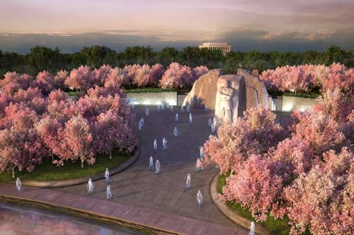
Along the Tidal Basin, Yoshino cherry blossom trees have thrived since 1912 – a gift from Japan as a sign of peace and unity. For only two weeks each spring, their tiny blossoms surround the Basin in a cloud of delicate pink and white. Spring resonates with the spirit of hope, rebirth and renewal; the King Memorial has added 182 cherry blossoms to the Tidal Basin’s collection. Poetically, each year the peak blooming period for the trees coincides with the anniversary of Dr. King’s assassination, April 4th.
To prolong the message of renewed hope embodied by the cherry trees, crape myrtles have also been planted in the memorial. Crape myrtles bloom throughout the summer months and into the fall, prolonging the burst of color and encouraging a sense of endurance and faith.
Along West Basin Drive and Independence Avenue 31 American elm trees have been planted, not only as the standard street tree of Washington, DC, but also as a border surrounding the memorial, embracing Dr. King as an American icon.
Water
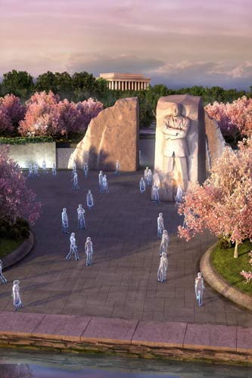
Drawing on its location at the edge of the Tidal Basin, water is used as an essential element that builds on King's words and recalls most powerfully the theme of justice. The water appears only on either side of the main entry, not even visible until one has entered the memorial plaza. It is the sound of water “rolling down” that will draw a visitor’s attention. From this life-giving source, Dr. King’s message begins stretching away from the entrance, at once welcoming and yet daring the visitor to follow.
Site | Design Elements | Composition and Space | Dr. King's Spiritual Presence

About the Memorial
Composition and Space
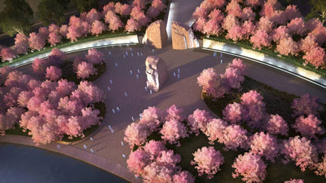
This memorial is not designed to be experienced in a single way with one single message, but rather it is to have a broad accessibility, appealing to all of the senses with diverse and overlapping themes. The introduction of an arcing berm into the horizontal arrangement of the site encourages the Mountain of Despair to be a threshold; after crossing it the visitor is isolated from the traffic along Independence Avenue. The visitors are then free to view, sit, meet, speak and congregate in large and small groups throughout the plaza.
The use of water creates an audible buffer, further enhancing the sensation of being enveloped within the space. Mists will help cool the environment in the warm summer months and rough hewn stone will recall the movement of falling water in the cold winter months. The varied textures of water, stone and landscape will create an environment that is inviting and functional in all seasons and from year to year.
Site | Design Elements | Composition and Space | Dr. King's Spiritual Presence
Design & Construction Team

About the Memorial
Dr. King's Spiritual Presence
Dr. Martin Luther King is remembered as a great orator whose impact on the nation came from the eloquence and inspirational quality of his words. His speeches, sermons and public addresses melded themes of democracy deeply embedded in the American conscience, and reinvigorated these messages with clear and insightful reflections on the true meaning of justice and equality.
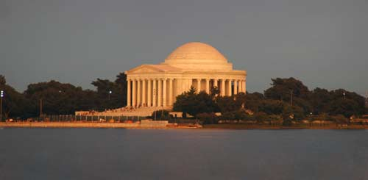
The Jefferson Memorial as seen from the Stone of Hope.
Within the memorial, quotes from Dr. King's sermons and speeches, are inscribed at a large scale on the smooth surfaces of the inscription wall. These passages will be reinforced through the referential use of water, stone, landscaping and light as metaphorical elements that heighten an awareness of his message.
All of the senses will be engaged through the experience of the memorial, and, foremost, through the visual perception of space, using contrast and juxtaposition, scale and height and the bold display of carefully selected words expressing his spirit. The inspirational text and the mood created by the sound of the water, its cooling mists, and the visual complexity of the contrasting rough and smooth surfaces of stone, the gradual changes in grade and the patterns of light and darkness will dramatically underscore the visual sense of the man and the qualities of courage, conviction and leadership that characterize his life and work.
Added to these powerful sensory experiences will be a sculptural representation of Dr. King himself. This is not conceived of as a pure figurative depiction of his physical being, separate and apart from other elements, but rather would give another dimension and layer of meaning to the experience of the memorial as a whole. Dr. King will appear as an integral part of the "Stone of Hope", as if he embodies the stone itself. He will be positioned on the side of the stone facing the Jefferson Memorial and will be gradually revealed as part of the procession towards the Tidal Basin.
"There are two types of laws: there are just laws and there are unjust laws...What is the difference between the two?...An unjust law is a man-made code that is out of harmony with the moral law...Paul Tillich has said that sin is separation. Isn't segregation an existential expression of man's tragic separation, an expression of his awful estrangement, his terrible sinfulness?"
– Martin Luther King, Jr., 1963
At first, as one enters the main space, the central stone will appear somehow cleft from the stones flanking the portal entry, but pushed forward so as to be visually isolated from the rest of the memorial grounds.
As one gets closer to the monolith, its rough hewn edges toward the memorial will begin to take on a vaguely familiar contour, recognizable, but not entirely clear.
Finally, as one looks back to the inscription wall and main space from the stone, the image of Dr. King will be fully revealed. He will be seen looking across the Tidal Basin. This representation will stir the emotions, transcend the physical and symbolic and directly engage the imagination of the viewer.
World peace through nonviolent means is neither absurd nor unattainable. All other methods have failed. Thus we must begin anew. Nonviolence is a good starting point. Those of us who believe in this method can be voices of reason, sanity, and understanding amid the voices of violence, hatred, and emotion. We can very well set a mood of peace out of which a system of peace can be built.
– Martin Luther King, Jr. December 1964
The entire memorial invokes the memory and spiritual presence of Dr. Martin Luther King, Jr. through the visual experience of place, reinforced by the full range of sensory perception, the metaphorical use of water, stone and other landscape elements, the powerful display of passages from his sermons and speeches and the appearance of his physical image in the "Stone of Hope".
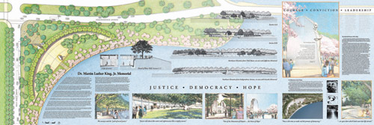
Winning Memorial Design. The winning design was submitted in January 2000 by ROMA Design Group of San Francisco, CA.

About the Memorial
Design & Construction Team
Designer
ROMA Design Group
1527 Stockton Street
San Francisco, CA 94133
www.ROMA.com
Design-Build Contractor
McKissack & McKissack / Turner Construction / Tompkins Builders / Gilford Corporation Design-Build Joint Venture
- McKissack & McKissack, Architect of Record
www.mckissackdc.com
- Turner Construction
www.turnerconstruction.com
- Tompkins Builders, Inc.
www.tompkinsbuilders.com
- Gilford Corporation
www.gilfordcorp.com
Site | Design Elements | Composition and Space | Dr. King's Spiritual Presence
Design & Construction Team

Leadership
The campaign to build a national memorial honoring Dr. Martin Luther King, Jr. is lead by a team of well-known public figures, respected representatives of various professions, and executives with some of America’s foremost business and industrial firms.
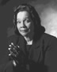
Coretta Scott King
In Memoriam
Founder, The King Center
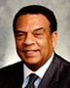  Ambassador Andrew Young  Chairman  GoodWorks International |   Gary Cowger  Global Group Vice President, Ret.  General Motors Corporation | John T. Montford  Chairman, GM Foundation  Senior Advisor, Government Relations  and Global Public Policy  General Motors Company  GoodWorks International
Executive Leadership Cabinet
David M. Cordani  President and CEO  CIGNA Corporation  Phillippe P. Dauman  President & CEO  VIACOM  George Foreman  Boxer and CEO  Foreman, Inc.  Dr. Robert M. Franklin  President  Morehouse College  Earl G. Graves  Chairman and CEO  Earl G. Graves Ltd.  Black Enterprise Magazine  William H. Gray, III  Chairman  The Amani Group  Vernon Jordan, Esq.  Senior Managing Director  Lazard Freres & Co., LLC  Honorable Alexis M. Herman  23rd U.S. Labor Secretary  Chair & CEO  New Ventures, Inc.  Thomas J. Hilfiger  Tommy Hilfiger, USA  Joel Horowitz  Ann and Joel Horowitz Family Foundation | Chad A. Jester  President  Nationwide Foundation  Sheila C. Johnson-Newman  CEO of Salamander Hospitality, LLC  Partner of Lincoln Holding LLC  President, Managing Partner and Governor  Washington Mystics  Honorable Jack Kemp  In Memoriam  Founder & Chairman  Kemp Partners  Victor B. MacFarlane  Managing Principal  MacFarlane Partners  J. W. Marriott, Jr.  Chairman & CEO  Marriott International, Inc.  Emilio Pardo  Chief Brand Officer  AARP  Dr. William F. Pickard  Chairman & CEO  Vitec, LLC  General Colin L. Powell  USA (Retired)  Franklin D. Raines  Revolution Health Group  Washington, DC | Henry Schleiff  President & CEO  The Discovery Channel  Ivan G. Seidenberg  Chairman & CEO  VERIZON Communications  Russell Simmons  Chairman & CEO  Rush Communications  Daniel Snyder  Owner  NFL Washington Redskins  David Stern  Commissioner  National Basketball Association  Dale A. Stinton  CEO  National Association of Realtors  J. C. Watts, Jr.  President & CEO  J. C. Watts Companies  Dr. Robert L. Wright  Chairman  F E Holdings

Presidents' Council
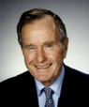  President George H. W. Bush | 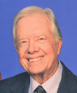  President Jimmy Carter
  President Bill Clinton | 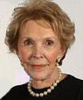  Nancy Reagan  (representing President Ronald Reagan)
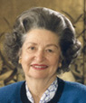
In memory of Lady Bird Johnson
(representing President Lyndon B. Johnson)

Dream Team
The Dream Team consists of celebrities who generously donate their time and resources to promote and support the Memorial.
Laila Ali  Muhammad Ali  Dr. Maya Angelou  Clarence Avant  Angela Bassett  Richard Brooks  Chris Brown  Roger Aaron Brown  Tommy Davidson  Suzzanne Douglas  Kenny "Babyface" Edmonds  Tracey Edmonds  Laurence Fishburne  Antwone Fisher  Harrison Ford  George Foreman  Vivica A. Fox  Morgan Freeman  Whoopi Goldberg  Dennis Haysbert  Dule Hill  Dustin Hoffman  Ernie Hudson  Samuel L. Jackson  Anne Marie Johnson | Patti La Belle  Walt "Baby" Love-Shaw  Peter Max  Holly Robinson Peete  Rodney Peete  Joseph C. Phillips  Paul Pierce  James Reynolds  Lionel Ritchie  Al Roker  Victoria Rowell  Carlos Santana  Deborah Santana  Oz Scott  Martin Sheen  Elisabeth Shue  Andrew Shue  Tavis Smiley  Jerry Stackhouse  Sean Patrick Thomas  Lorraine Touissant  Dr. Debbye Turner  Dionne Warwick  Chris Webber  Brad Whitford

Board of Directors
Board Chairman  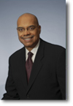  Roderick Gillum  Partner  Jackson Lewis LLP  Southfield, MI | Board Vice Chairman  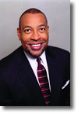  Guy Vickers  President  Tommy Hilfiger Corporate Foundation  New York, NY
Directors
David Drummond  Vice President, Corporate Development & General Counsel  Google, Inc.  Mountain View, CA  Arthur L. Fleming  First Vice President and Director  Community Investment Services  Federal Home Loan Bank of Atlanta  Atlanta, GA  Steven R. Gursky  Partner  Olshan, Grundman, Frome, Rosenzweig & Wolosky, LLP  New York, NY  Frank Jenkins  CEO  Jenkins & Associates, Inc.  Montgomery, AL  Honorable Patrick J. Kennedy  U.S. House of Representatives  Washington, DC  Herman "Skip" Mason  General President  Alpha Phi Alpha Fraternity, Inc.  Atlanta, GA  Tyrone Means  Attorney at Law  Thomas, Means, Gillis, & Seay, P.C.  Montgomery, AL  Vivian R. Pickard  President, GM Foundation  Director, Corporate Relations General Motors Company  Detroit, MI | Reverend Joe Ratliff  Senior Pastor  Brentwood Baptist Church  Houston, TX  George N. Reaves  Social Insurance Specialist  Social Security Administration  Harold Washington Social Security Center.  Chicago, IL  Frank Russell, Jr.  Atlanta, GA  Caryl M. Stern  Chief Operating Officer  US Fund for UNICEF  New York, NY  Robert Wingo  President & CEO  Sanders/Wingo Advertising, Inc.  El Paso, TX  Chris Womack  Executive Vice President and President  External Affairs  Southern Company  Atlanta, GA  Tonya R. White-Evans  Thomas, Means, Gillis, & Seay, P.C.  Montgomery, AL

Executive Staff
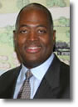 | Harry E. Johnson, Sr.  President & CEO  Dynamic Leadership  Harry E. Johnson, Sr. serves as President and CEO of the Foundation. A partner in a Houston, Texas law firm, under his leadership, the Foundation has made steadfast advancement toward completing the Memorial Project.
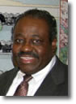 | Richard W. Marshall  Chief Financial Officer  Sound Fiscal Management  Richard W. Marshall, a finance director on loan to the organization from General Motors, serves as Chief Financial Officer of the Foundation, providing fiscal and financial management expertise. He has provided similar services for non-profit organizations throughout his career.
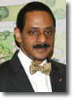 | Dr. Ed Jackson, Jr.  Executive Architect  Continuity in Project Management  Dr. Ed Jackson, Jr. serves as the executive architect of the Foundation, providing both management and continuity of the design and construction processes from beginning to end.
To contact any of the members of the Executive Staff please call (202) 737-5420.

Design-Build Team of the Washington, DC Martin Luther King, Jr. National Memorial
The McKissack & McKissack/Turner/Gilford/Tompkins Team is a highly qualified, experienced and diverse design, management and building team. Founded on mutual goals, trust and character, each member of this Design-Build Team has contributed their key corporate strengths as well as best and brightest professionals for this landmark project.
Team members have relevant experience working together. To illustrate, McKissack and Turner have had a successful relationship since 1996. Together, the two firms have completed many high-profile projects, including the New Washington Convention Center, Renovation of RFK Stadium and the Multi-phased Renovation of the U.S. Treasury Building. McKissack and Turner are currently managing the construction of the New Nationals Major League Baseball Stadium as well as providing project management services in support of the Washington Convention Center Headquarters Hotel and Expansion Space project. Furthermore, Gilford Corporation and Turner are jointly performing comprehensive preconstruction services for Broadcast Center One in Washington, DC, and are both working with McKissack on the District of Columbia Public Schools Modernization Program. Gilford Corporation is also teamed on the new National Harbor project in Prince George’s County with Tompkins Builders, Inc.
McKissack & McKissack of Washington, Inc. is an African-American, woman-owned full service architecture and program/construction management firm. Deryl McKissack, PE, PMP, founded the company in 1990, which now has offices in Washington, DC, Baltimore, Chicago and Miami. McKissack employs 140 professionals and is certified by the District of Columbia as a Local, Small and Disadvantaged Business Enterprise (LSDBE). It is ranked by the Washington Business Journal as one of the top 25 Design firms in the Washington Metropolitan Area and by Engineering News Record as one of the nation’s leading Construction Management firms.
When Deryl McKissack established the company, she was the fifth generation of her family to carry on the building tradition. McKissack is an outgrowth of the oldest, continually minority-owned architecture/engineering firm in the United States. Its roots go back to before the Civil War, when a slave in Tennessee named Moses McKissack learned the building trade from his overseer. It was his grandson, Moses III, who launched the first McKissack & McKissack in Nashville, Tennessee. The year was 1905.
The year that Ms. McKissack’s father took the helm of the Nashville firm, Dr. Martin Luther King, Jr. was assassinated in Memphis at the Lorraine Motel. A civil rights center was later constructed within the motel that would help visitors better understand the history and lessons of the American Civil Rights Movement. McKissack & McKissack of Nashville provided full architectural and engineering services for the $9.9 million renovation and addition for the civil rights center.
Today, the fifth generation of McKissacks still understands the importance of legacy and tradition, especially in the historic preservation of landmarks and erection of monuments, notably its performance as prime contractor on the design-build work at the Lincoln and Jefferson Memorials. For the past six years, McKissack has provided services for the restoration and security improvements for both the Lincoln and Jefferson Memorials. The firm’s memorial experience has also included construction management for the U.S. Air Force Memorial site preparation. Moreover, in celebration of the McKissack family’s centennial year, in 2005 Ms. McKissack’s firm bequeathed the concept design for the fundraising effort for the new Cape Coast Museum in Ghana. The museum was designed to represent the seven stages Africans went through in being taken from their homeland, to becoming slaves, to some eventually becoming free in the United States.
Turner Construction Company was founded by Henry C. Turner in 1902. Throughout his career, Mr. Turner referred to his clients as “respected friends”. The company quickly built a strong reputation for integrity, teamwork and commitment. One of the largest and most established General Contractors in the United States, Turner put in place more than $8.5 billion in construction in 2006. With its 5,500 employees worldwide, the firm consistently ranks number one or two in the Engineering News Record major building category rankings.
Turner has maintained a full service local office in the Washington region since 1975 and employs more than 420 professionals. The company offers the following benefits: 105 years of financial strength and stability; local, national and international resources and operations; and unmatched design-build, preconstruction and construction experience.
Turner has a long, positive track record in utilizing small firms and Minority/Women-Owned Business Enterprises (M/WBEs). Turner’s objective is to increase visibility, improve economic viability, and expand opportunities for these businesses. Since 1979, Turner’s total awards to M/WBEs and involvement with M/WBE joint venture partnerships exceeds $14.4 billion. It has established an annual goal of 20% relative to the utilization of M/WBEs in the areas of construction, subcontracting, prime contracting, joint venture relationships/associations, and goods and services. Moreover, Turner has developed a successful Construction Management Training Program for M/WBEs, an eight-week course taught by professional Turner staff volunteers on such topics as risk management, construction estimating, safety and effective marketing. Today, more than 15,000 people have successfully graduated from this program.
Gilford Corporation is a leading minority-owned firm established in 1984 as Gilford & Chase, a civil engineering firm. In 1995, the firm’s focus became construction, changed its name to Gilford Corporation, and became certified with the Small Business Administration 8(a) and the District of Columbia as a Local, Small and Disadvantaged Business Enterprise (LSDBE), among others. Since that time, Gilford Corporation has experienced significant growth and completed over 350 projects with an aggregate value of more than $180 million (excluding joint ventures).
Gilford Corporation currently employs an ethnically and culturally diverse staff numbering approximately 180 and offers multidiscipline services through its four operating divisions: general contracting and construction management; demolition and environmental services; information technology and network services; and international construction and network services.
Tompkins Builders, Inc. became a wholly-owned subsidiary of Turner Construction Company in 2003. Tompkins is an important asset of Turner because of its long standing history of service in the District of Columbia. Frequently, Turner and Tompkins Builders share staff, technologies and resources to provide the best project team and performance available to clients.
Tompkins Builders is responsible for some of the District’s most unique, prominent, and historically significant projects, including: National World War II Memorial; National Museum of Natural History renovations; Ronald Reagan Building; National Gallery of Art East Wing; National Gallery of Art Sculpture Garden; Thomas Garrigue Masaryk Memorial; US Capitol East Front Extension; National Air and Space Museum renovation; Old Post Office Pavilion; and American Red Cross Headquarters.
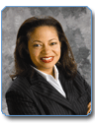
Deryl McKissack, PE, PMP, McKissack & McKissack—Executive Oversight. Ms. McKissack is President and Chief Executive Officer of McKissack. She founded the company in 1990 as a sole entrepreneur working with very limited financial resources. Through her leadership, vision, and passion for excellence, she has defined the culture of the firm. Prior to launching her own company, Ms. McKissack worked directly with the President of Howard University. Her leadership at the institution was marked by successfully managing a $32 million operating budget and capital budget exceeding $200 million, which covered three campuses, 133 buildings and 900 employees. Earlier in her career, she worked for both Turner Construction Company and Dames & Moore Group.
Ms. McKissack serves on the Board of Directors of the National Building Museum, Living Classrooms Foundation and DC Economic Club. She participates on Advisory Boards for the DC Lottery and University of the District of Columbia Foundation. Additionally, Ms. McKissack is a member of the Federal City Council in Washington, DC, Metropolitan Planning Commission in Chicago, the Executive’s Club of Chicago, National Forum of Black Public Administrators, Corporate Advisory Council (National, Chicago and Washington, DC Chapters) as well as the Construction Management Association of America and is a former member of the Architecture/Engineering Review Board for the Department of Housing and Community Development.

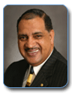
Hilton Smith, Turner Construction Company—Senior Vice President, Corporate and Community Affairs. In his current position, Mr. Smith is responsible for managing the company’s corporate affairs, Minority/Woman-owned Business Enterprise Program, equal employment and educational programs. He coordinates business development and strategic marketing programs with senior executive officers in the company. Mr. Smith has actively led Turner’s efforts in awarding over $20 billion to thousands of minority- and woman-owned business enterprises. In 2005, Turner reached the $1 billion mark in its M/WBE program.
Mr. Smith’s education includes a BA in Sociology & Political Science from St. Augustine’s College as well as Urban Studies at Cleveland State University, completion of the Urban Ministry Program at Yale University, and Doctor of Humane Letters (honorary) from David Meyers University.

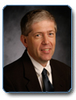
Christian E. Jahrling, Turner Construction Company—Vice President and General Manager of Turner's Mid-Atlantic regional office. He is responsible for the day-to-day management of the firm with particular focus on the technical and contractual aspects of government, commercial, and healthcare projects. He has 25 years of experience with Turner.
Prior to becoming the regional General Manager, Chris headed Turner's Government Services division. Under his leadership Turner successfully installed baggage screening equipment at all U.S. Airports under a TSA national design-build contract - 447 in all. Chris also has experience as the General Manager of Turner's Detroit offices, overseeing major Turner projects including the Green Bay Packers stadium renovations, Comerica Ball Park, and the General Motors Headquarters renovations.

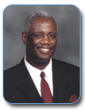
Henry Gilford, Gilford Corporation—Executive Oversight. As President and Chief Executive Officer, Mr. Gilford oversees the corporation’s strategic management, marketing and business development. He also has executive responsibility for firm operations. Mr. Gilford provides leadership and executive supervision for all projects, proposal development, contract negotiations, and client relations. He is personally involved in all project aspects to ensure the firm’s mission is accomplished in each project. Under Mr. Gilford’s leadership, Gilford Corporation accomplishes this objective through partnership, teamwork, planning, training, communication, attention to detail and the belief that excellence and professional relationships are paramount to the firm’s success. Mr. Gilford earned a BS in Construction Engineering from Alabama A&M University. He holds Civil Engineering Certifications and Registrations in the District of Columbia and elsewhere.


Ken Terry, Tompkins Builders, Inc.—Project Executive. Mr. Terry has nearly 15 years of experience in the construction industry. His background includes historic and new construction projects. He has repeatedly demonstrated his results-oriented approach by progressively being assigned many of Tompkins most challenging projects. During the span of his tenure in the industry, Mr. Terry has executed construction assignments that have had difficult site restrictions, complex excavation, and intricate sheeting and shoring and structural requirements. Among his most notable projects are the National World War II Memorial, Saint Elizabeths New Hospital, Gallery Place Mixed-Use Redevelopment, and the Ronald Reagan International Trade Center Structural Concrete and Exterior Stone Facade Packages. Mr. Terry received his BS in Civil Engineering from Virginia Tech.


Lisa Anders, McKissack & McKissack—Sr. Program Director. Ms. Anders possesses over 18 years of construction project management experience in both the public and private sector markets. Over the course of her career, Ms. Anders has acquired extensive hands-on project management and field experience in all phases of programming preconstruction, construction administration, cost estimating, scheduling, contract negotiations, and project close-out. Prior projects include, National Archives II, Pentagon Renovation, Cleveland Clinic Lerner Research Institute, Cleveland Clinic’s Cole Eye Institute, and Oriole Park at Camden Yards. Ms. Anders received her BS in Civil Engineering from Howard University and an MBA from University of Maryland.

Quick Facts About the Memorial
1. Why build a Memorial to Dr. King?
More than a monument to a great humanitarian, the National Memorial honoring Dr. Martin Luther King, Jr. will be a place for visitors from all over the world to be energized by its extraordinary power; the power that illuminated the faith of our founders and now impels us toward our destiny as a nation; the power flowing from the uniquely American spirit of brotherly love, freedom, justice, and the priceless blessing they endure...peace.
2. Why build the Memorial now?
Dr. King once reminded the nation of “the fierce urgency of now” while warning against “the tranquilizing drug of gradualism.” The time is now a historical perspective. Many young people have heard of Dr. King, but are unaware of the significance of his contributions to America and the world. The design has been established; the site is secured; the fundraising teams are already at work; and more than $114 million of the campaign goal has been raised. The time is now.
3. What will the Memorial look like?
The Memorial is conceived as an engaging landscape experience to convey four fundamental and recurring themes throughout Dr. King’s life – democracy, justice, hope, and love. Natural elements such as the crescent-shaped-stone wall inscribed with excerpts of his sermons, and public addresses will serve as the living testaments of his vision of America. The centerpiece of the Memorial, the “Stone of Hope”, will feature a 30-foot likeness of Dr. King.
4. When will the Memorial be completed?
The Ceremonial Groundbreaking occurred on November 13, 2006. The start of construction is contingent upon raising $120 million. The Dedication of the Memorial is tentatively scheduled for 2011.
5. How much will the Memorial cost?
It is estimated that the total cost of the project will be $120 million. Of that amount, more than $114 million has been raised.
6. To date, who have been your major contributors?
General Motors | $10,000,000
Federal Appropriation | 9,852,876
Tommy Hilfiger Corporate Foundation | 6,000,000
Alpha Phi Alpha Fraternity, Inc. | 3,485,208
Bill & Melinda Gates Foundation | 3,000,000
W.K. Kellogg Foundation | 3,000,000
NBA | 3,000,000
The Walt Disney Company | 2,750,000
In-Kind (Promotions and Marketing) | 1,300,000
Coca-Cola Foundation | 2,000,000
The Ford Motor Fund | 2,000,000
MetLife Foundation | 2,000,000
Toyota | 2,000,000
Verizon Foundation | 2,000,000
Delta Air Lines and Delta Air Lines Foundation | 1,600,000
MTTG a joint venture of McKissack & McKissack, Turner, Tompkins and Gilford | 1,400,000
Aetna | 1,275,000
Travelers | 1,250,000
Credit Unions of the United States | 1,200,000
GE | 1,200,000
AFSCME | 1,061,979
AARP | 1,000,000
AFLAC | 1,000,000
Best Buy | 1,000,000
The Boeing Company | 1,000,000
BP America, Inc. | 1,000,000
CIGNA | 1,000,000
Cummins | 1,000,000
DirecTV | 1,000,000
DuPont | 1,000,000
Exelon Foundation | 1,000,000
ExxonMobil Foundation | 1,000,000
Fannie Mae Corporation | 1,000,000
FedEx Corporation | 1,000,000
Ann and Joel Horowitz Family Foundation | 1,000,000
Sheila C. Johnson-Newman | 1,000,000
John S. and James L. Knight Foundation | 1,000,000
George Lucas | 1,000,000
MacFarlane Partners | 1,000,000
The J. Willard and Alice S. Marriott Foundation | 1,000,000
McDonald’s Corporation | 1,000,000
National Association of Realtors (NAR) | 1,000,000
National Education Association (NEA) | 1,000,000
National Football League Players Association | 1,000,000
Nationwide Foundation | 1,000,000
PepsiCo Foundation | 1,000,000
Pew Charitable Trusts | 1,000,000
Pfizer Foundation | 1,000,000
Prudential Financial, Inc. | 1,000,000
Shell Oil Company | 1,000,000
State Farm Insurance | 1,000,000
United Health Group | 1,000,000
Viacom; BET; MTV | 1,000,000
Wal-Mart | 1,000,000
Sony Pictures Entertainment | 650,000
AT&T | 600,000
The Annie E. Casey Foundation | 500,000
CBS | 500,000
Honda | 500,000
Morehouse College | 500,000
State of Maryland | 500,000
Procter & Gamble | 431,200
American Federation of Teachers | 300,000
Macy’s Foundation | 300,000
Marathon Oil | 300,000
Pepco | 300,000
Combined Federal Campaign (CFC) | 283,281
Bank of America Charitable Foundation | 250,000
Chevy Chase Bank | 250,000
Continental Airlines | 250,000
CVS Caremark Charitable Trust | 250,000
Lehman Brothers | 250,000
Southern Company | 250,000
Alpha Kappa Alpha Sorority | 170,000
Government of the District of Columbia | 150,000
Philip L. Graham Fund | 150,000
Xerox | 150,000
Delta Sigma Theta Sorority | 137,000
Emerson | 125,000
Trehan Foundation | 125,000
Illinois Tool Works | 110,000
Geico Philanthropic Foundation & Associates | 103,432
Trinity United Church of Christ | 102,142
And 1 Basketball | 100,000
Rod and Leslie Aycox Family Foundation | 100,000
Bloomberg | 100,000
Circuit City Foundation | 100,000
John Deere and Company | 100,000
Dyer Family Foundation | 100,000
Entergy Corporation | 100,000
Fannie Mae Foundation | 100,000
General Mills | 100,000
Johnson Controls | 100,000
Merrill Lynch | 100,000
Charles Miller Memorial Foundation | 100,000
Motorola | 100,000
Charles Stewart Mott Foundation | 100,000
Parsons Family Foundation | 100,000
Deborah and Carlos Santana | 100,000
The Embassy of South Africa | 100,000
Key Bank Foundation | 100,000
Grassroots Initiative | 2,172,462
Other Contributions: | 5,562,419
Total Contributions as of 5/23/2011 | $112,396,999
7. What can I do to help?
Individuals as well as corporations can add their financial support to this effort. Contributions, large and small, are needed to attain our goal of $120 million. Spread the word to your friends, neighbors and acquaintances that their donations are urgently needed.

